Name: Rakshitha. V. B.
Register No: 192324004
UNIT 3
Scenario 1: Why Clean Data?
Problem:
A dataset contains missing values and inconsistent data formats. We need to clean it before
analysis.
Python
import pandas as pd
# Sample raw data
data = {
"Name": ["Alice", "Bob", None, "Charlie", "David"],
"Age": [25, "Thirty", 29, None, 22],
"Salary": [50000, 55000, 60000, 58000, "Sixty-Five Thousand"]
}
df = pd.DataFrame(data)
print("Raw Data:")
print(df)
# Data Cleaning
df["Name"] = df["Name"].fillna("Unknown")
df["Age"] = pd.to_numeric(df["Age"], errors="coerce")
df["Salary"] = df["Salary"].replace("Sixty-Five Thousand", 65000).astype(int)
print("\nCleaned Data:")
print(df)

Output:
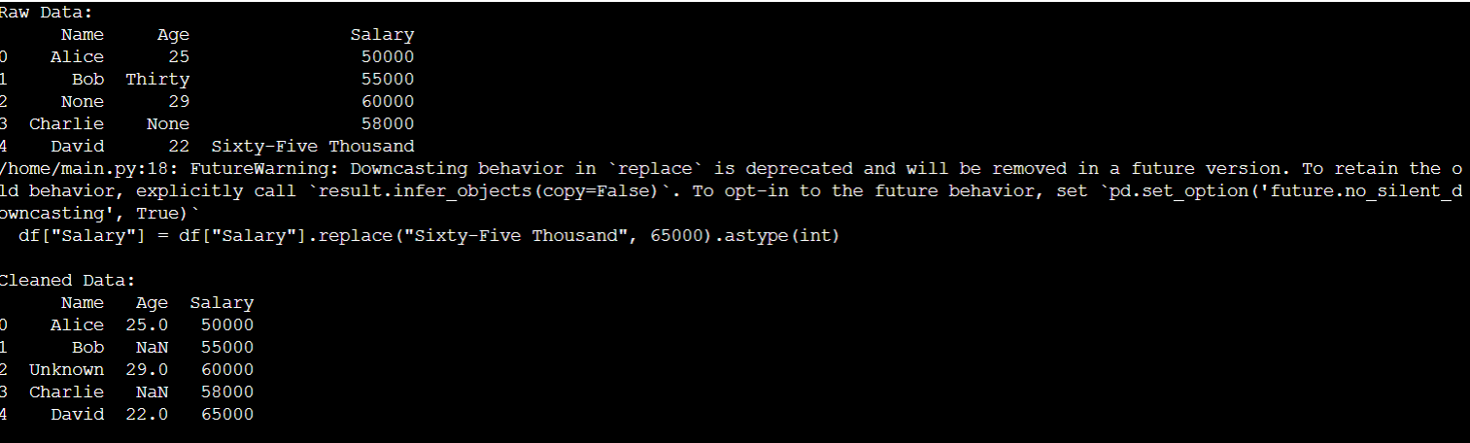
Scenario 2: Identifying Values for Data Cleanup
Problem:
Identifying missing values and incorrect entries in a dataset.
import pandas as pd
data = {
"Name": ["Alice", "Bob", "Unknown", "Charlie", "David"],
"Age": [25, None, 29, None, 22],
"Salary": [50000, 55000, 60000, 58000, 65000]
}
df = pd.DataFrame(data)
print("Missing Values Count:")
print(df.isnull().sum())
print("\nData Types:")
print(df.dtypes)

Output:
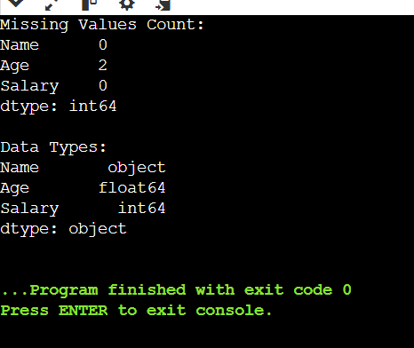
Scenario 3: Formatting Data
Problem:
The Date column is in multiple formats. We need to standardize it.
import pandas as pd
data = {
"Date": [
"2025-01-01",
"01-02-2025",
"03/05/2025",
"April 7, 2025"
]
}
df = pd.DataFrame(data)
df["Date"] = pd.to_datetime(df["Date"])
print(df)
Output:
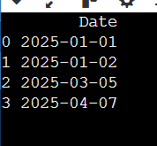

Scenario 4: Finding Outliers and Bad Data
Problem:
Detecting outliers in the Sales column using the IQR method.
import pandas as pd
import numpy as np
data = {
"Sales": [200, 250, 300, 1500, 260, 270, 280, 10000]
}
df = pd.DataFrame(data)
Q1 = np.percentile(df["Sales"], 25)
Q3 = np.percentile(df["Sales"], 75)
IQR = Q3 - Q1
lower_bound = Q1 - 1.5 * IQR
upper_bound = Q3 + 1.5 * IQR
outliers = df[(df["Sales"] < lower_bound) | (df["Sales"] > upper_bound)]
print("Outliers:")
print(outliers)

Output:
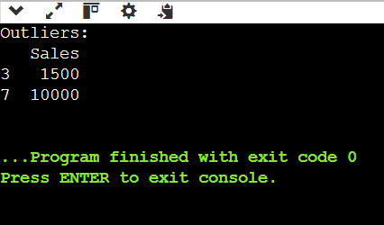
Scenario 5: Finding Duplicates
Problem:
Identifying and removing duplicate records in a dataset.
import pandas as pd
data = {
"ID": [1, 2, 3, 2, 4, 5, 3],
"Value": [100, 200, 300, 200, 400, 500, 300]
}
df = pd.DataFrame(data)
duplicates = df[df.duplicated()]
print("Duplicates Found:")
print(duplicates)
df_cleaned = df.drop_duplicates()
print("\nCleaned Data:")
print(df_cleaned)
Output:
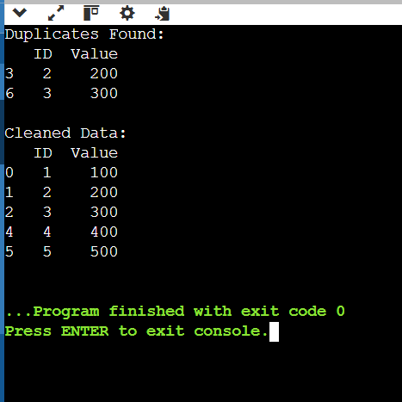
Scenario 6: Fuzzy Matching
Problem:
from fuzzywuzzy import process
names = [
"John Doe",
"Jon Doe",
"Jane Doe",
"J0hn Doe"
]
query = "John Doe"
matches = process.extract(query, names, limit=3)
print("Fuzzy Matches:")
print(matches)
Output:
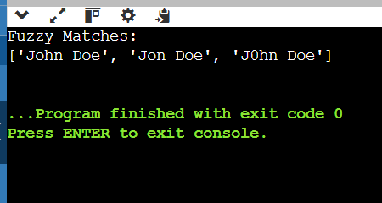
Scenario 7: RegEx Matching
Problem:
Finding invalid email formats using regex.
import re
emails = [
"test@example.com",
"user.name@domain.com",
"invalid-email@",
"hello@world"
]
def is_valid_email(email):
pattern = r'^[a-zA-Z0-9_.+-]+@[a-zA-Z0-9-]+\.[a-zA-Z0-9-.]+$'
return bool(re.match(pattern, email))
invalid_emails = [email for email in emails if not is_valid_email(email)]
print("Invalid Emails:")
print(invalid_emails)
Output:
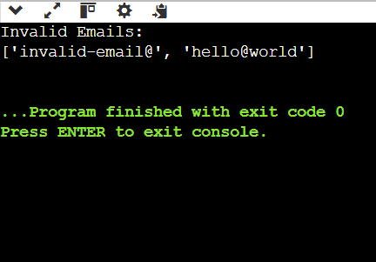
Scenario 8: Normalizing and Standardizing Data
Problem:
Standardizing a column using Min-Max scaling.
import pandas as pd
from sklearn.preprocessing import MinMaxScaler
data = {
"Value": [100, 200, 300, 400, 500]
}
df = pd.DataFrame(data)
scaler = MinMaxScaler()
df["Normalized"] = scaler.fit_transform(df[["Value"]])
print(df)
OUTPUT
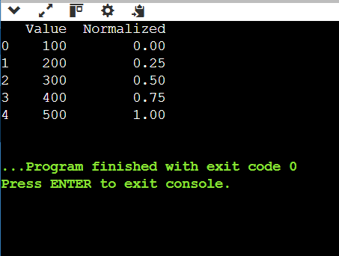
Scenario 9: Saving the Data
Problem:
Saving the cleaned data to a CSV file.
import pandas as pd
data = {
"ID": [1, 2, 3],
"Value": [100, 200, 300]
}
df = pd.DataFrame(data)
df.to_csv("cleaned_data.csv", index=False)
print("Data saved successfully.")
OUTPUT
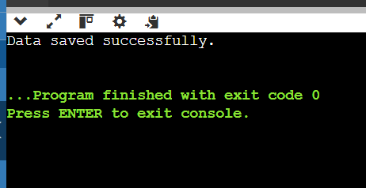
Scenario 10: Automating Data Cleanup with a Script
Problem:
import pandas as pd
data = {
"Name": ["Alice", None, "Bob"],
"Age": [25, "Thirty", None]
}
df = pd.DataFrame(data)
def clean_data(df):
df = df.fillna("Unknown")
df["Age"] = pd.to_numeric(df["Age"], errors="coerce")
return df
df = clean_data(df)
print(df)
OUTPUT
